**VIETNAM NATIONAL UNIVERSITY, HO CHI MINH CITY**

**HO CHI MINH CITY UNIVERSITY OF TECHNOLOGY**

**OFFICE FOR INTERNATIONAL STUDY PROGRAMS**

**FACULTY OF TRANSPORTATION**

**Capstone Project**

**Analysis, 3D modeling and dynamic simulation of the vehicle**

**steering system in the VIOS car.**

**Instructor: Ph.D Ngô Đắc Việt**

**Ph.D Trần Đăng Long**

**Name: Trịnh Tiến Long**

**Student ID: 1852047**

May 22th, 2023, Ho Chi Minh City, Vietnam

**🙦 Semester 222**

**VIETNAM NATIONAL UNIVERSITY OF HO CHI MINH CITY** **SOCIALIST REPUBLIC OF VIETNAM**

**HO CHI MINH UNIVERSITY OF TECHNOLOGY Independence – Freedom – Happiness**

Faculty of Transportation Engineering

Department of Automotive Engineering

**PROJECT MISSION**

1. **Student’s name**: Trịnh Tiến Long - Student ID: 1852047
2. **Major**: Automotive Engineering - Class: CC19OTO1
3. **Thesis title**: Analysis, 3D modeling and dynamic simulation of the vehicle steering system in the VIOS car.

**Content:**

_Build EPS model on Solidworks then import to Simscape to determine the torque acting on steering wheel with certain steering angle on EPS system

_Build 3D model of the steering system

_Simulation of dynamic behavior in Matlab/Simulink with Simscape

_Validation the model for the control of an equivalent electric powered steering system

1. Product:
   * Full report.
   * Poster.
   * Simulink simulation.
2. **Assigned day**: ${23}^{th}$ December, 2022
3. **Finished day**: ${22}^{th }$ May, 2023

The content and requirements of the thesis is already approved by the Head of Department of Automotive Engineering.

HCMC, day….... month…… year 2023 HCMC, day… . month…… year 2023

**Head of Department** **Instructor**

# ACKNOWLEDGEMENT

I would like to express my gratitude to the most important people in my academic journey.

Firstly, I want to thank my family for their unwavering support and encouragement throughout my studies. Their presence and guidance have been invaluable in shaping who I am today.

I am also grateful to the dedicated teachers at Bach Khoa University, especially those in the Department of Automotive Engineering, for sharing their knowledge and expertise with me. Their teachings over the past four years have equipped me with the skills and confidence to complete this thesis.

I would like to extend my gratitude to my mentors, PhD. Ngo Dac Viet and PhD. Tran Dang Long, for providing me with opportunities to learn, practice, and conduct field surveys. Their guidance and feedback have been instrumental in my academic growth.

Lastly, I want to thank the reviewer and department lecturers for their insightful feedback and suggestions, which have helped me refine my thesis. To my classmates in CC19OTO1, thank you for your camaraderie and support.

I wish my parents, family, lecturers in the Faculty of Transportation Engineering, as well as lecturers in the Department of Automotive Engineering, and all my friends good health and happiness.

# ABSTRACT

This study presents a simulation of an Electric Power Steering (EPS) system using MATLAB Simulink and Simscape, based on the parameters of a Toyota VIOS passenger car with front-wheel drive.

The EPS model was built using SolidWorks and was designed to simulate the steering behavior of the VIOS under different driving conditions. The simulation results show that the EPS system provides the desired steering response for different driving conditions.

The study includes two parts: In the first part, the EPS system's responsiveness was evaluated by applying more torque on the steering wheel without help from motor. The simulation results showed that the steering system responded quickly to changes in steering input, providing accurate and responsive steering control.

In the second part, the study evaluated the torque changes needed to maintain a predefined driving situation. The simulation results showed that the EPS system provided the necessary torque changes to keep the VIOS on the desired path, demonstrating the system's effectiveness in maintaining vehicle stability.

The study also analyzed the effects of different parameters, such as the steering gear ratio and the controller gains, on the EPS system's performance. The simulation results showed that adjusting these parameters had a significant impact on the EPS system's performance, and that proper tuning of these parameters is essential for achieving optimal performance.

Overall, the simulation results demonstrate the effectiveness of the EPS system in providing responsive and accurate steering control for a Toyota VIOS passenger car with front-wheel drive. The study provides insights into the design and performance evaluation of EPS systems for this specific vehicle model, which could be useful for future research and development in this area.

**Table of Contents**

ACKNOWLEDGEMENT 2

ABSTRACT 3

I/ Introduction: 7

**1)** **Objective:** 7

a) About Electric Power Steering System 7

b) About Matlab/Simscape 7

c) Objective 10

**2)** **Scope of implementation:** 10

The scope of this thesis is to analyze the dynamic behavior of the Electric Power Steering (EPS) system in the VIOS model, by creating a simulation model in MATLAB/Simulink. Aerodynamic simulations will not be included, the analysis will be limited to lower speeds. 10

**3)** **Working condition:** 10

**4)** **Technical requirement:** 10

**5)** **Limitation** 11

**6)** **Conditions and Requirements for Building Simulation Models, Conditions for Applying Matlab Simulink/Simscape Software** 11

II/Parameter of Electric Power Steering Model 12

**1.** **Complete 3D model** 12

**2.** **Parameter and design for each part** 12

**a.** **Parameter table** 12

**b.** **3D model of each part** 12

**3.** **How to export from Solidworks to Simulink on MATLAB** 15

III/ Theoretical basics: 26

**1.** **Kinematics of the steering trapezium:** 26

**2.** **Creating a path for simulation** 28

IV. MATLAB/SIMULINK SIMULATION 30

**1.** **General information about block is used** 30

1.1) Complete model 30

1.2) Steering dynamics block 32

1.3) Total resistance torque block 33

1.4) Vehicle 3DOF Dual track block 34

1.5) Some specialized blocks are used to create a predefined path and apply a force that simulates human reactions to stay on that path. 34

**2.** **Dynamic steering system** 35

2.1) Block corresponding to the part in Mechanics Explorer 35

2.2) Simulation scenarios 36

V. CONCLUSION AND FUTURE WORK 42

Appendix 45

VII. REFERENCE 46

**Table of Figures**

Figure 1: Complete 3D model of Electric Power Steering 12

Figure 2: Rack 13

Figure 3: Pinion 13

Figure 4: Tie rod 14

Figure 5: Steering Linkage 14

Figure 6 : Add-Ins 16

Figure 7: Turn Add-ins on 16

Figure 8: Export to .xml file 17

Figure 9 : Opening Folder 18

Figure 10: Command Window 19

Figure 11 : Use smimport command to import 19

Figure 12: Steering Dynamic 20

Figure 13: Mechanics Explorers 21

Figure 14 : Complete model in Simulink 31

Figure 15: Operation Flow of Complete model 31

Figure 16 : Complete model 32

Figure 17: Operation Flow of Steering Dynamic 33

Figure 18: Total resistance torque 33

Figure 19 : Set Path and Driver block 34

Figure 20: Model Simulation at 1km/h 37

Figure 21: Real Vehicle Testing 38

Figure 22:Real Vehicle Testing at 1km/h 38

Figure 23: Model Simulation at 5km/h 39

Figure 24: Real Vehicle Testing at 5km/h 40

Figure 25: Result Comparision 42

# I/ Introduction:

## **Objective:**

1. About Electric Power Steering System

During the past ten years, EPS has been introduced in gradually increasing numbers. Although electric power steering system offer significant advantages over their hydraulic counterparts, electric motor technology and controls had not reached the point where they could be used in this application until just recently. Electrically assisted power steering is replacing the traditional hydraulic system where the pressure is provided via a pump driven by the vehicles engine. The hydraulic system is constantly running and by using the EPS the fuel consumption can be reduced. In electric and hybrid vehicles, the engine does not run continuously so electric power steering is the only possible solution.

Advantages:

* EPS is more energy-efficient than hydraulic power steering systems, resulting in improved fuel economy.
* EPS is quieter than hydraulic systems because it doesn't require a hydraulic pump.
* EPS offers better control and quicker response times, as the level of power assist can be adjusted based on the vehicle's speed and other factors.
* EPS can be integrated with other electronic safety features like lane departure warning and stability control.

Disadvantages:

* EPS systems can be more expensive to repair or replace than hydraulic systems.
* Some drivers may find that EPS lacks the same level of feedback and "feel" as hydraulic systems, leading to a less engaging driving experience.
* EPS systems can be heavier than hydraulic systems because they require an electric motor to provide the power assist.
* In the event of a power failure, EPS may become difficult or impossible to operate, whereas hydraulic systems would still function with greater effort required from the driver.

1. About Matlab/Simscape

Simscape is a physical modeling language and simulation tool in MATLAB that enables engineers to design and simulate multidomain physical systems. This tool allows engineers to create models that represent the behavior of physical systems, including electrical, mechanical, hydraulic, and thermal systems, among others. With Simscape, engineers can model systems at a higher level of abstraction, which simplifies the creation and analysis of complex systems.

Simscape provides pre-built components and libraries that engineers can use to design and build models. These components and libraries can be customized to meet specific modeling requirements and can be combined to create complex systems. For example, an engineer can use a pre-built hydraulic pump component and combine it with a pre-built valve component to create a hydraulic system. This flexibility allows engineers to design and simulate diverse physical systems.

Simscape offers a visual representation of simulation results, which is an essential feature for understanding system behavior. Engineers can visualize simulation results in the form of graphs, plots, and animations. This capability allows engineers to analyze and interpret system behavior more effectively.

Simscape also offers several other features that make it a powerful tool for physical modeling and simulation. For instance, it allows engineers to perform parameter sweeps and sensitivity analyses, which can be used to optimize system performance. Additionally, Simscape can be integrated with other MATLAB tools, such as Simulink, to create more complex models that include control systems and other components.

Overall, Simscape is a powerful tool that enables engineers to model and simulatecomplex physical systems more efficiently and accurately. It provides an intuitive platform for designing and analyzing multidomain physical systems, making it a valuable tool for engineers in various fields, including mechanical, electrical, and aerospace engineering. With its vast library of pre-built components and simulation capabilities, Simscape can help engineers design and optimize complex systems, reduce development costs, and improve overall system performance.

|  |  |  |  |
| --- | --- | --- | --- |
| **Tool** | **Concept** | **Application** | **Advantages** |
| Matlab | Software | Calculation and simulation | Widely-used platform, versatile, powerful numerical computation abilities, supports graphical user interface (GUI) for easy visualization and interaction with data, offers a large library of built-in functions and toolboxes for various applications, supports various file formats for importing/exporting data, can be integrated with other programming languages. |
| Simscape | Physical modeling language | Modeling physical systems | Allows for modeling and simulation of complex physical systems with ease, supports multi-domain modeling (e.g. electrical, mechanical, hydraulic), provides a library of pre-built components for easy modeling, offers a unified platform for modeling and simulation, can be integrated with Matlab for further analysis and visualization. |
| Simulink | Block diagram modeling | Dynamic system modeling and simulation | Provides a graphical user interface for modeling, simulating, and analyzing dynamic systems, supports a wide range of modeling and simulation tasks (e.g. continuous-time, discrete-time, hybrid systems, etc.), offers a large library of pre-built blocks for various applications, supports automatic code generation for embedded systems, provides real-time simulation capabilities, supports co-simulation with other software and hardware systems, offers various analysis and visualization tools for system analysis and optimization. |

1. Objective

The objective of this content is to demonstrate the process of building an Electric Power Steering (EPS) model using Solidworks and Simscape, creating a 3D model of the steering system, simulating the EPS system's dynamic behavior in Matlab/Simulink with Simscape, and validating the model for the control of an equivalent electric-powered steering system. The primary goal is to determine the torque acting on the steering wheel with a certain steering angle on the EPS system and to provide insights into the design and evaluation of EPS systems for future research and development in this area.

1. **Scope of implementation:**

The scope of this thesis is to analyze the dynamic behavior of the Electric Power Steering (EPS) system in the VIOS model, by creating a simulation model in MATLAB/Simulink. Aerodynamic simulations will not be included, the analysis will be limited to lower speeds.

1. **Working condition:**

Constant steering angle, constant speed: In this scenario, the VIOS vehicle will be driven at a constant speed on a predetermined road, while the steering angle is kept constant. The purpose of this scenario is to evaluate the performance of the electric power steering system in maintaining the steering angle at a constant value, given the driving conditions and the characteristics of the road.

Following a predefined road: In this scenario, the VIOS vehicle will be driven on a predefined road with a set of steering commands to follow the road. The steering commands will be generated based on the road curvature and the desired speed. The purpose of this scenario is to evaluate the performance of the electric power steering system in tracking the desired steering commands and following the road accurately, given the driving conditions and the characteristics of the road.

## **Technical requirement:**

Correct technical specifications are ensured to guarantee that the system operates within specified parameters with low margin of error.

1. **Limitation**

The limitation of this study is that the parameters based on the VIOS vehicle were measured at an automotive workshop at the HCM University of Technology, so they may not be entirely accurate.

## **Conditions and Requirements for Building Simulation Models, Conditions for Applying Matlab Simulink/Simscape Software**

|  |  |
| --- | --- |
| **Conditions for building models and applications Matlab Simulink - Simscape** | **Technical requirements** |
| Establishing a compatible linkage between the Solidworks graphics environment and Matlab Simulink. | Building a mechanism model that closely matches reality on Solidworks and linking it to Matlab. |
| In terms of kinematics, the steering system is analyzed as a series of steps, linked together by rotating or sliding joints. | Identifying the component steps and types of linkage between them. |
| The mating steps in the entire mechanism are interconnected through established linkages. | Establishing the correct type of linkage for each step, setting up a common coordinate system, and coordinates on each step as a basis for locating the position of each step in space. |
| Using functional blocks in the Simulink library linked to the model to establish a program for testing the working parameters of the mechanism. | Determining the theoretical basis for testing the working process and providing input parameters corresponding to the working process. |
| Converted from the Solidworks model to an equivalent Simscape model for ease of communication between the two software programs. | Checked whether the mating steps were converted correctly as per practical requirements. |

# II/Parameter of Electric Power Steering Model

* + - 1. A picture containing wheel, tire, auto part, transport

         Description automatically generated**Complete 3D model**

Figure 1: Complete 3D model of Electric Power Steering

* + - 1. **Parameter and design for each part**
         1. **Parameter table**

|  |  |
| --- | --- |
| **Name** | **Value** |
| Rack | 0.37m |
| Pinion:Rack ratio | 1:3 |
| Track Width | 1.4m |
| Tie Rod | 0.265m |
| Steering Linkage | 0.1m |

* 1. **3D model of each part**

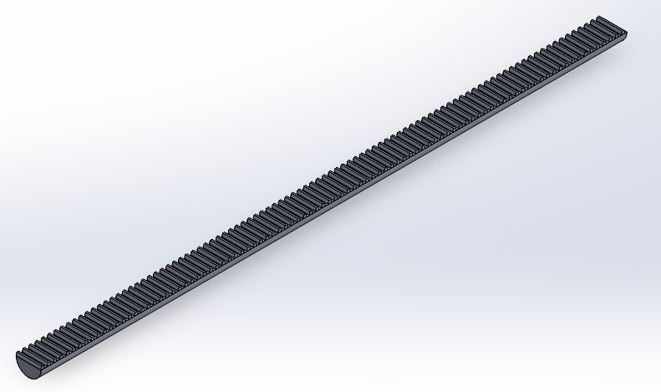

Figure 2: Rack

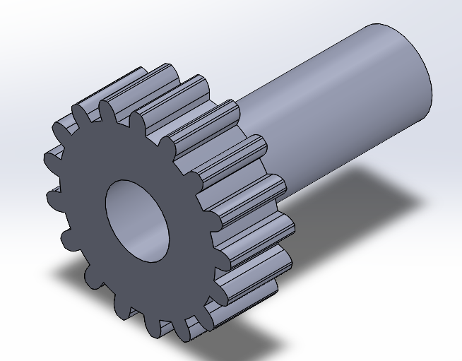

Figure 3: Pinion

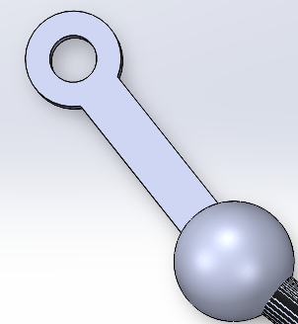

Figure 4: Tie rod

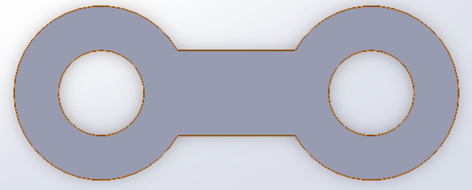

Figure 5: Steering Linkage

| **Parameter** | **Unit** | **Value** |
| --- | --- | --- |
| Wheelbase | mm | 2550 |
| Distance between two vertical pillars | mm | 1470 |
| Radius of steering wheel | mm | 180 |
| Steering gear ratio |  | 19.5 |
| Wheel radius | mm | 354 |
| Number of teeth on the pinion |  | 9 |
| Number of teeth on the rack |  | 27 |

Table : Parameter of model

Other parameters will be listed in table above.

* + 1. **How to export from Solidworks to Simulink on MATLAB**

**Step 1:** Enable Simscape Multibody Link Plugin in SolidWorks

The Simscape™ Multibody™ Link plugin allows SolidWorks® CAD assembly models can be exported to Simscape Multibody. To download and install the plugin, watch on:  [Install the Simscape Multibody Link Plugin](https://www.mathworks.com/help/smlink/ug/installing-and-linking-simmechanics-link-software.html).

**Enable the Plugin**

To enable the plugin:

1. At the MATLAB® command prompt, enter [smlink_linksw](https://www.mathworks.com/help/smlink/ref/smlink_linksw.html).
2. Start SolidWorks.
3. On the SolidWorks menu bar, click **Tools** > **Add-Ins**.

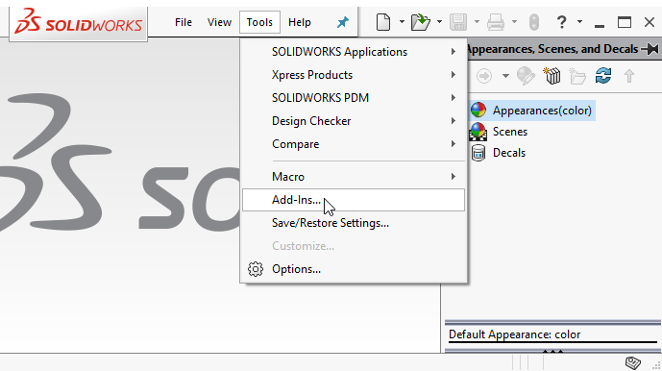

Figure 6 : Add-Ins

1. In the Add-Ins dialog box, select the **Simscape Multibody Link** check box.

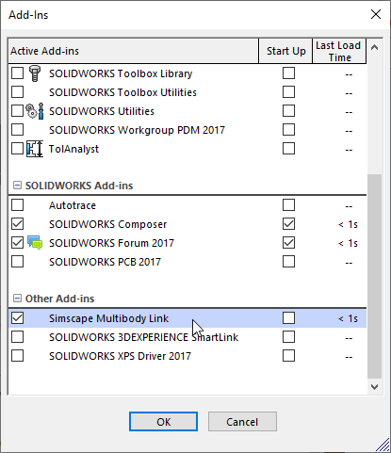

Figure 7: Turn Add-ins on

After enabling the plugin, **Simscape Multibody Link** option is available when SolidWorks assembly is opened. To export an assembly model, on the menu bar, click **Tools** > **Simscape Multibody Link** > **Export** > **Simscape Multibody**.

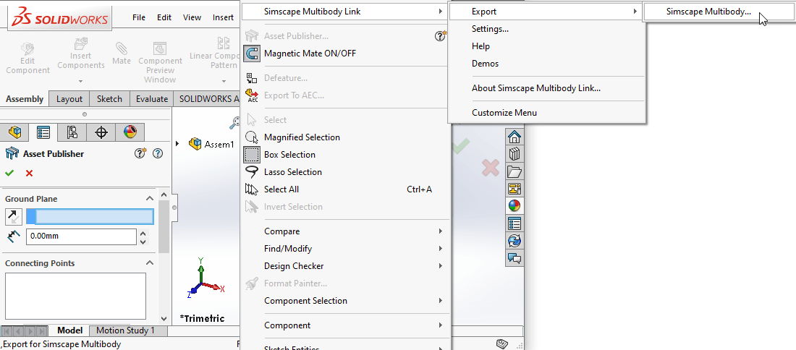

Figure 8: Export to .xml file

**Step 2**: Use smimport to get .xml file that exported from Solidworks to Simulink

1. To export an assembly drawing to Matlab Simulink, we need to open the drawing file type Assembly go to Add-Ins and click Export Simscape Multibody, choose where to save the file and file name (usually the file name is recommended by name drawing Assembly), the file will be created in the .xml which is format of Simscape Multibody Link.

2. To open the file, first after starting Matlab need to select the folder containing file: click Browse for folder and select the folder containing the file, then click Select Folder

Figure 9 : Opening Folder

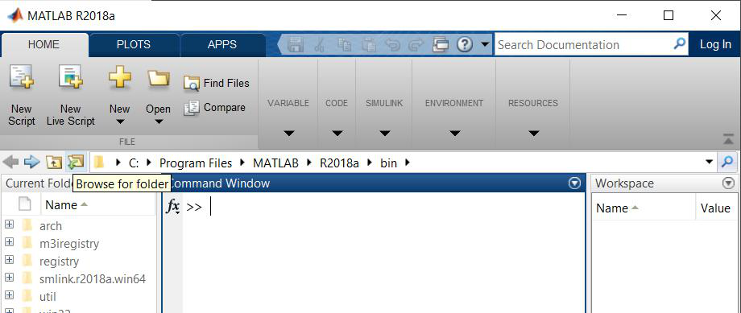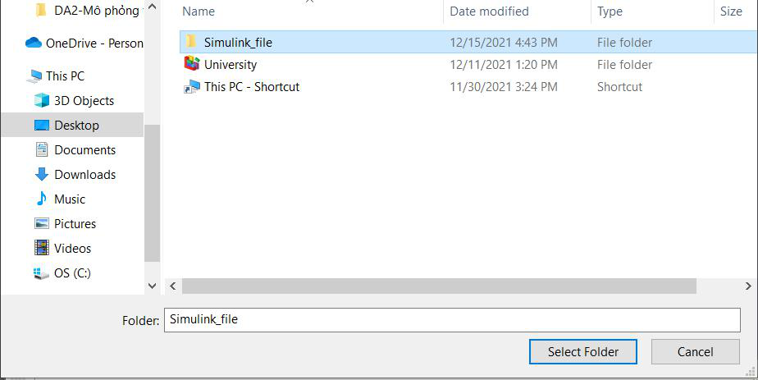

3. In the Command Window in Matlab, enter the command smimport(‘filename.xml') and wait for the importing model to finish running

Figure 10: Command Window

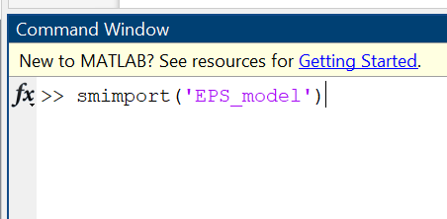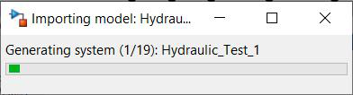

Figure 11 : Use smimport command to import

converted to Matlab Simulink as functional blocks

Figure 12: Steering Dynamic

1. In the Simulink window, you can select Run and check if the mechanism runs as designed in the Mechanics Explorers dialog box

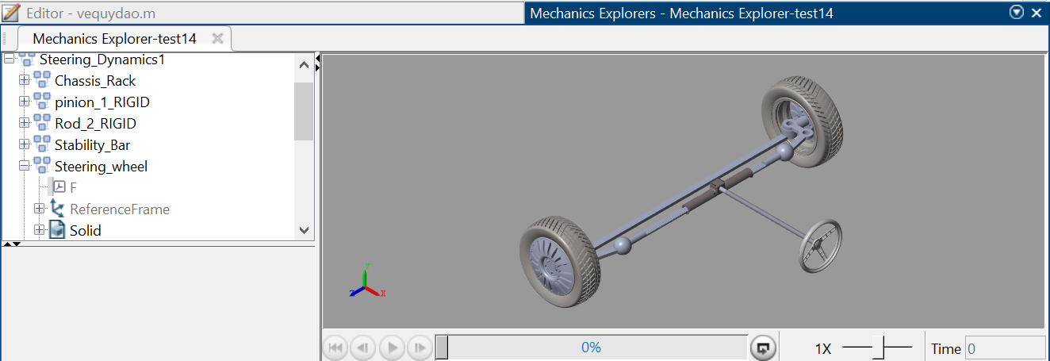

Figure 13: Mechanics Explorers

| **Name and Symbol** | **Function and Configuration** |
| --- | --- |
| Subsystem | Contains a set of blocks within a model or system. A Subsystem block may represent a virtual subsystem or a nonvirtual subsystem. For example, in Figure 5.1, there are Subsystem blocks for Fluids, Simulink, Multibody, etc. |
| Inport | Brings a signal from outside a system into the system. The port number of an Inport block is assigned as follows: it is automatically numbered sequentially in the highest-level system or subsystem. If a new Inport block is added, its label is the next available number. If an Inport block is deleted, the port numbers of other blocks are automatically reassigned to ensure that the Inport blocks are numbered sequentially and that no numbers are skipped. If an Inport block is copied into a system, its port number is not reassigned unless its current number conflicts with an existing input port in the system. If the Inport block's port number is not sequential, renumber the block. Otherwise, an error message will be received when simulating or updating the block diagram. |
| Outport | Sends a signal from a system to an external destination. They can connect signals transmitted from a subsystem to other parts of the model. They can also provide the top-level outputs of a hierarchical model. The port number of an Outport block is assigned as follows: Outport blocks in the base-level system or subsystem are numbered sequentially, starting with 1. If a new Outport block is added, it is assigned the next available number. If an Outport block is deleted, the port numbers of other blocks are automatically reassigned to ensure that the Outport blocks are numbered sequentially and that no numbers are skipped. |
| Connection Port | This block is used in a subsystem when physical ports need to be connected. |
| Mechanism Configuration | Sets mechanical parameters and applies simulation for the entire machine, target machine that the block is connected to. In the Properties section below, we can specify a uniform gravity force for the entire mechanism and set linear delta t. Port C is the frame node that we connect to the target machine with a connection path at any frame node of the machine. |
| World Frame | Provides a space with a stationary, orthogonal coordinate frame, defined by the right-hand rule, in any mechanical model. The World Frame is the basis of all frame networks in a mechanical model. A model can have multiple World Frame blocks, but they all represent the same frame. Port W is a frame port defined with the World Frame. Any frame port directly connected to W is also defined with the World Frame. |
| Rigid Transform | Determines a fixed 3D rigid transformation between two frames. The two components independently specify the translational and rotational parts of the transformation. Translation and rotation motions can be combined freely. Ports B and F correspond to the Base and Following Frames, respectively. |
| Revolute Joint | Connects two frames with a hinge joint that has only one degree of freedom. Port B corresponds to the Base and F corresponds to the Following Frames. In the expandable nodes under Properties, we can specify state targets, actuation methods, sensing, and internal mechanics. |
| Reference Frame | Defines a frame to which other frames in the network can be referenced or blocks can be attached. (Optional) Port R is a frame port defined with the reference frame. Any frame port directly connected to R is also defined with the reference frame. |
| Cylindrical Joint | Connects two frames with a cylindrical joint that has one translational and one rotational degree of freedom. Port B corresponds to the Base and F corresponds to the Following Frames. In the expandable nodes under Properties, we can specify state targets, actuation methods, sensing, and internal mechanics (equilibrium position, spring stiffness, damping coefficient) of these joints (one translation along Z and one rotation around Z). After applying these settings, the block will display corresponding physical signal ports. |
| Planar Joint | Represents a planar joint between two frames. This joint has two translational and one rotational degree of freedom. Port B corresponds to the Base and F corresponds to the Following Frames. In the expandable nodes under Properties, we can specify state targets, actuation methods, sensing, and internal mechanics (equilibrium position, spring stiffness, damping coefficient) of these joints (two translations along X and Y and one rotation around Z). After applying these settings, the block will display corresponding physical signal ports. |
| Prismatic Joint | Connects two frames with a prismatic joint that has only one translational degree of freedom. Port B corresponds to the Base and F corresponds to the Following Frames. In the expandable nodes under Properties, we can specify state targets, actuation methods, sensing, and internal mechanics (equilibrium position, spring stiffness, damping coefficient) of this joint (one translation along Z). After applying these settings, the block will display corresponding physical signal ports. |
| Gain | The Gain block multiplies the input signal by a constant value (gain). The input can be a scalar, vector, or matrix signal. The value of the Gain can be specified in the Gain parameter. The Multiplication parameter allows us to specify element-wise or matrix multiplication. For matrix multiplication, this parameter also allows us to specify the order of the multiplication. |
| Signal Editor | The Signal Editor block displays, creates, and edits signal parameters that can be exchanged between blocks. This block can be used to convert signal parameters inside and outside the model. |
| Converter | The Converter block converts Simulink signals to physical signals. |
| PS Constant | The PS Constant block generates a physical signal with a constant value. The value and unit of the signal can be specified as a constant. |
| Solver Configuration | The Solver Configuration block specifies the solver parameters required for a Simscape block diagram to start simulation. Each Simscape block diagram has a unique structure and connectivity that requires an accurate Solver Configuration block to be connected to it. The solver configuration parameters include the type of solver to be used, the maximum step size, the relative and absolute tolerances, the maximum number of iterations, and other solver-specific options. The Solver Configuration block allows the user to specify these parameters and configure the solver accordingly. Choosing the appropriate solver configuration is important for obtaining accurate and efficient simulation results. The default solver configuration in Simscape is suitable for most models, but for complex models or those with stiff differential equations, a different solver configuration may be necessary for accurate and efficient simulation. |
| PS-Simulink Converter | The PS-Simulink Converter block converts physical signals to Simulink signals. |
| Scope | The Scope block displays the signals generated during simulation. It can be used to visualize the behavior of different signals and debug the model. |
| Mux | The Mux block combines separate signals into a single vector signal. This block can be used to combine multiple signals into a single signal for further processing or analysis. |

# III/ Theoretical basics:

* + - 1. **Kinematics of the steering trapezium:**

Theoretical basis for calculating the kinematics of the steering trapezium

According to the theory of wheel rotation, the ideal turning condition for the wheels to avoid lateral slipping is:



where:

* **βi**: the turning angle of the inner steering wheel (degrees);
* **δi**: the turning angle of the outer steering wheel (degrees);
* **L**: the wheelbase of the vehicle (mm);
* 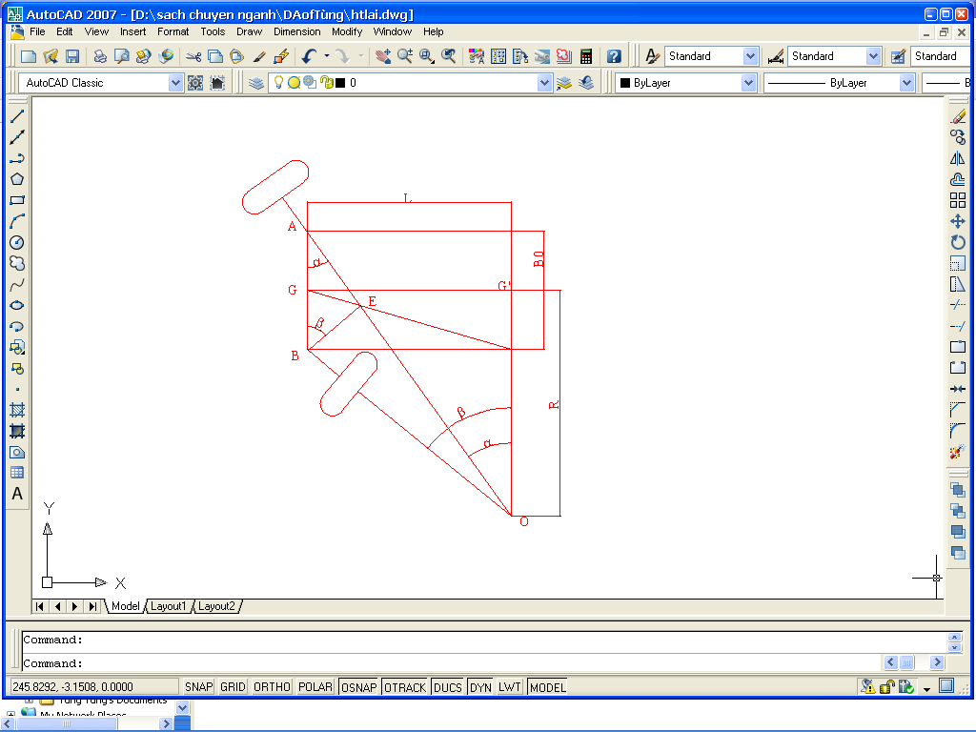**B0**: the track width of the vehicle (mm).

From Figure above, we have: angle (GAE) = α (the turning angle of the outer steering wheel).

We have: cotg αi =  substituting into above equation, we get:



Therefore, the turning angle of the inner steering wheel β is equal to angle (GAE). From this, by substituting the pairs (αi, βi) from above formula into the diagram, we can obtain the intersection points Ei lying on the line GC. This ensures that the kinematics of the steering trapezium allows the vehicle to turn without lateral slipping.

However, in reality, the steering trapezium does not satisfy the above condition, which means that the actual values of the pairs (αi, βi) do not satisfy equation , causing the steering wheels to still experience lateral slipping. The degree of lateral slipping is minimized when the intersection points Ei are as close as possible to the line GC.

**\* Checking by algebraic method**

The algebraic method evaluates the degree of lateral slipping through the coefficient δi, which is determined by the following formula:



* Determine the values of the coefficient δi corresponding to each pair of different angles (αi, βi) according to formula above.
* The closer the values of δi are to 1, the less lateral slipping occurs when the vehicle turns with different radii.
* The specific calculation results according to formula above are compiled into the table below:

|  |  |  |
| --- | --- | --- |
| **βi(degree)** | **αi (degree)** | **δi** |
| 5 | 4,75 | 0,98 |
| 10 | 9,07 | 0,94 |
| 15 | 13,03 | 0,98 |
| 20 | 16,69 | 0,99 |
| 25 | 20,1 | 0,99 |
| 30 | 23,31 | 0,95 |
| 35 | 26,38 | 0,97 |
| 40 | 29,33 | 0,98 |

Table : Checking kinematic of model

For the cars currently in use, the oscillation coefficient δi is within the range of δ = 0.9 to 1.07. Therefore, based on the calculation results, it can be seen that the steering trapezium of the vehicle, which has specifications similar to the Toyota Vios, ensures that the turning condition is met without lateral slipping.

* + - 1. **Creating a path for simulation**

To accurately model the control rules of an electric power steering system, it is imperative to create a realistic driving scenario that involves the driver turning the steering wheel to the left or right. Therefore, the driving scenario will be lane changing.

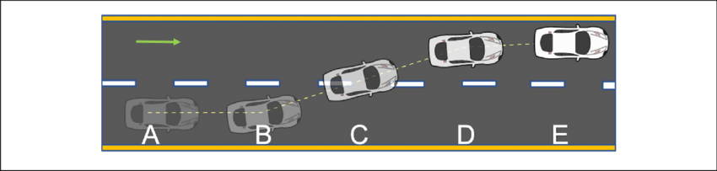

To create this driving scenario, the vehicle motion needs to be tracked so that the driver can adjust the steering wheel so that the vehicle will move in a preset path. This motion can be controlled by considering the displacement of the vehicle along x and y axis of the earth-fixed coordinate. However, as a PID controller will be used as a driver, it cannot control both variables (x and y displacement), so we need a variable that can present the displacement of the vehicle according to both x and y. As a result, heading angle of the vehicle will be the variable to be controlled.

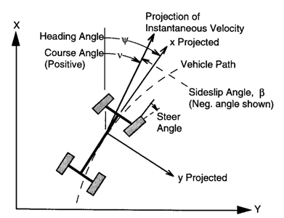

Heading angle of a vehicle is the angle between the moving direction and a fixed reference point, which in this driving scenario will be the x axis. In other words, it is the direction in which the vehicle is traveling relative to x axis. This heading angle will be calculated by as yaw (rad) a MATLAB block - Vehicle Body 3DOF, which will be described later.

Heading angle will be calculated as:

$$θ=arctan⁡(\frac{dy}{dx})$$

From the above formula, we first create a table consisting of x and y coordinates of the car over time. Then, divide derivative of y by derivative of x to obtain the heading angle. From there, we have a lookup table of heading angles corresponding to each x coordinate of the vehicle.

From the original position where the car travels the dx distance, we will get a new x coordinate, now through the above lookup table, the heading angle is obtained. Use the new heading angle to calculate the new dx distance and repeat, similar to y. As a result, for each dx and dy, we will find the set heading angle for the car.

According to the coordinate system of the Vehicle Body 3DOF block in MATLAB, the vehicle will start moving in the direction x so x will be the path and y will be the distance between the 2 lanes. At different speeds, the distance x will increase or decrease to match reality. Y will have a maximum value of 3.5 because this is a standard width of a lane.

# IV. MATLAB/SIMULINK SIMULATION

**General information about block is used**

* 1. Complete model

A complete model has been developed for testing in various scenarios including Steering Dynamics that is built by 3D model in Solidworks and Total resistance torque

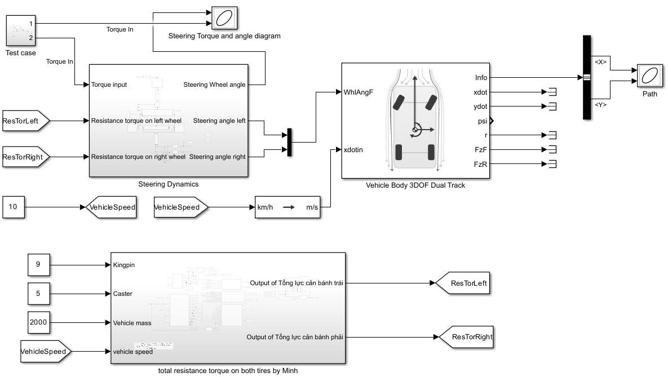

Figure 14 : Complete model in Simulink

To be specific, the input and output are used in this project will be shown below:

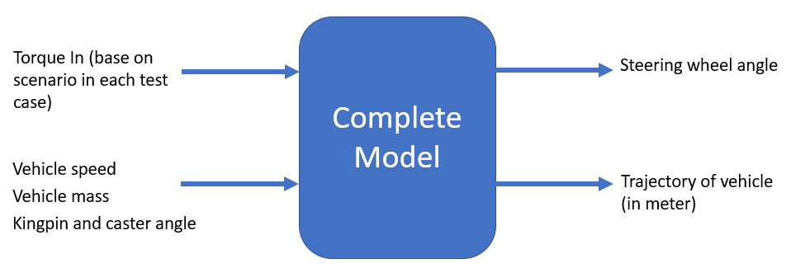

Figure 15: Operation Flow of Complete model

* 1. Steering dynamics block

Figure 16 : Complete model

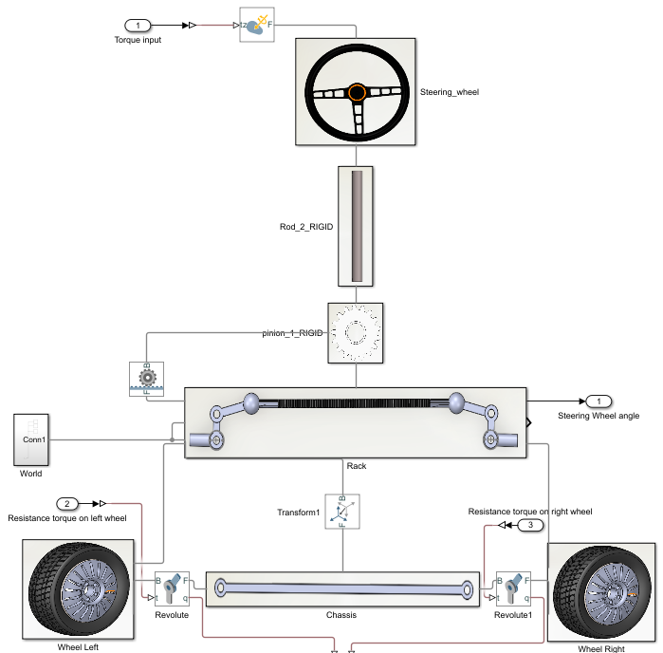

After building 3D models on SolidWorks, using Matlab/ Multibody to build dynamic models and simulate the models to evaluate the technical characteristics of the Electric steering system.

To be specific, the input and output are used in this block will be shown below:

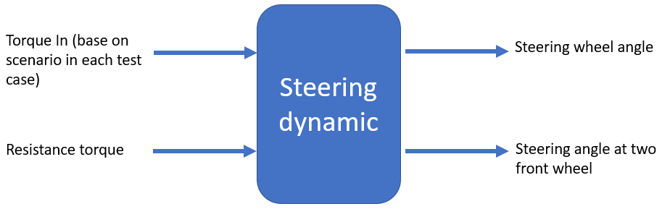

Figure 17: Operation Flow of Steering Dynamic

* 1. Total resistance torque block

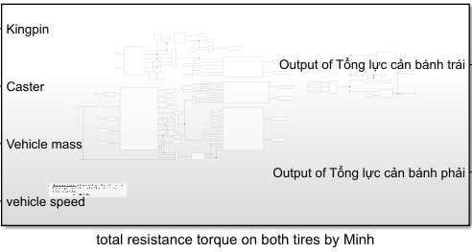

Figure 18: Total resistance torque

This block receives inputs such as Kingpin, Caster, Vehicle Mass, and Speed, and outputs the resistance torques at the left and right wheels.

* 1. A diagram of a remote control

     Description automatically generated with low confidenceVehicle 3DOF Dual track block

This block takes in the steering angle at the front wheel (WhlAngF) and the vehicle speed in the x-direction (xdotin), and outputs the **trajectory** of the vehicle as a combination of its X and Y coordinates.

* 1. Some specialized blocks are used to create a predefined path and apply a force that simulates human reactions to stay on that path.

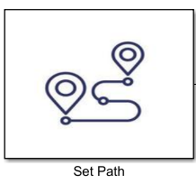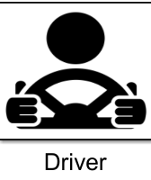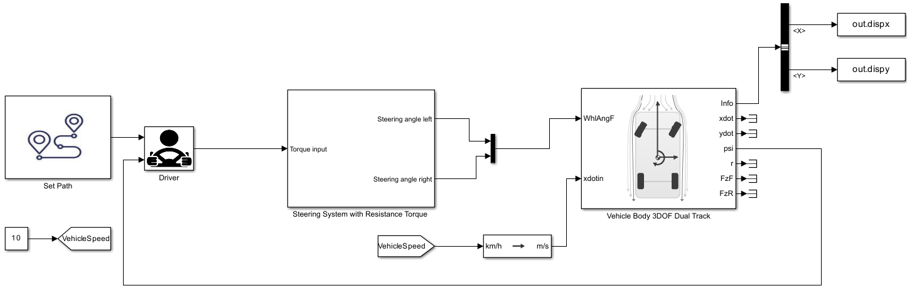

Figure 19 : Set Path and Driver block

Set Path block : from predefined path, this block gives output is heading angle of vehicle needed

Driver block : getting heading angle from ‘Set Path’ and Vehicle Body 3DOF Dual Track

1. **Dynamic steering system**

### 2.1) Block corresponding to the part in Mechanics Explorer

Determining the corresponding block or module for a part in Mechanics Explorer is crucial for understanding and analyzing the properties and performance of the system's components. By identifying the corresponding block or module, parameters and settings of that block can be observed and adjusted them to achieve the design goals or analyze the system's performance. This part can be the focus of a thesis or research paper in the field of system dynamics.

### 2.2) Simulation scenarios

a. Relationship between torque input and steering wheel angle

To understand the relationship between torque input and steering wheel angle, two test case has been developed. Both test case use parameters in below table:

|  |  |
| --- | --- |
| Parameters | Value |
| Vehicle mass (full load) | 1520kg |
| Caster | 5 degree |
| Camber | 9 degree |

In first scenario, vehicle will run with v=1km/h, we get the result:

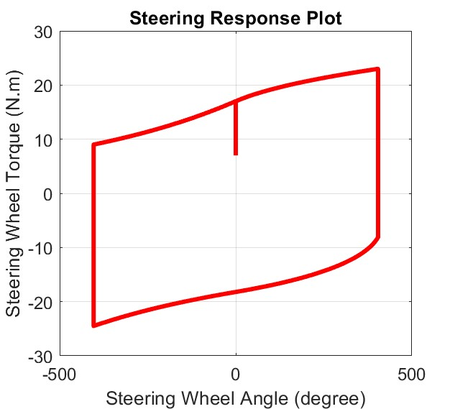

Figure 20: Model Simulation at 1km/h

Comparison with real vehicle experiments is recommended to validate the relationship between steering torque and vehicle speed observed in this study.

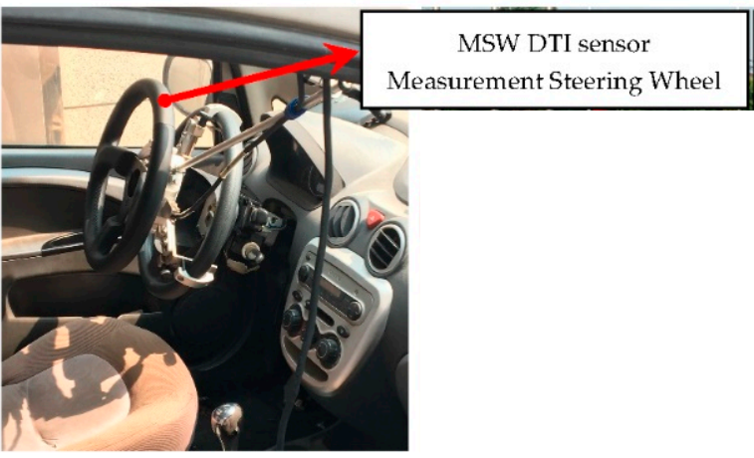

Figure 21: Real Vehicle Testing

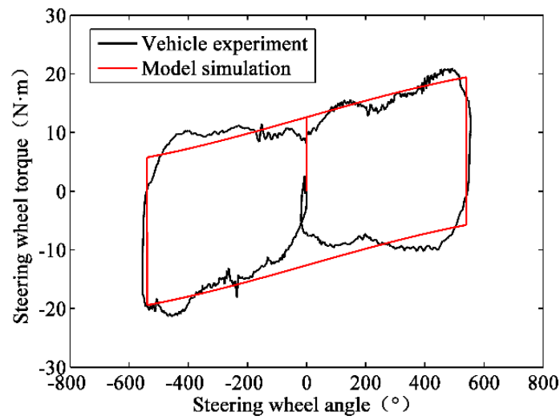

Figure 22:Real Vehicle Testing at 1km/h

In second scenerio, vehicle will run with v=5km/h, we get the result:

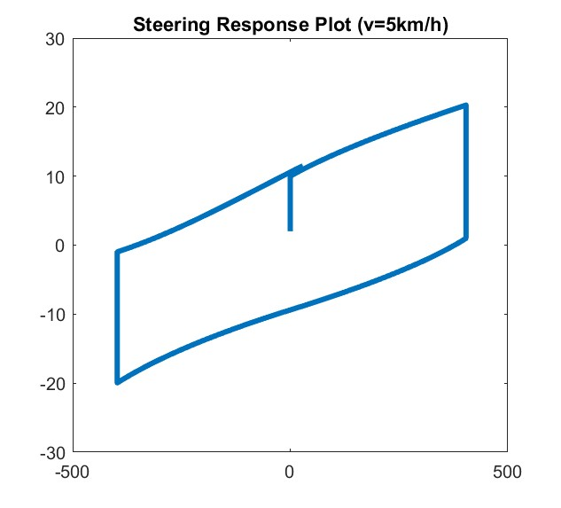

Figure 23: Model Simulation at 5km/h

Similarly, diagram below shows the relationship between torque and steering wheel angle at 5km/h

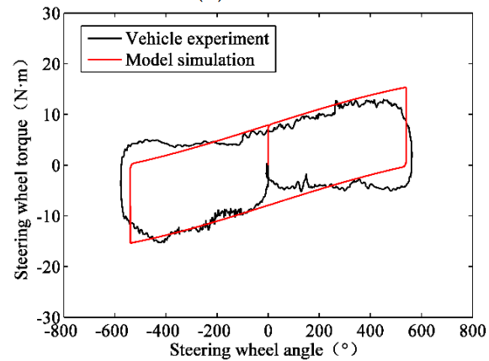

Figure 24: Real Vehicle Testing at 5km/h

By conducting both simulation and real vehicle testing, we were able to observe that the simulation results closely matched the real-world results. This close agreement between the simulation and real-world testing provides a strong validation of the simulation model, and underscores the value of using simulation to investigate complex engineering problems. The ability to accurately simulate real-world behavior can help to reduce the need for costly and time-consuming physical testing, and can provide valuable insights into the performance and behavior of complex systems. Overall, the close agreement between the simulation and real-world results highlights the effectiveness and reliability of simulation as a tool for engineering design and analysis.

b. Vehicle follows predefined trajectory

In this scenario, lane-changing scenario will be setup as predefined trajectory

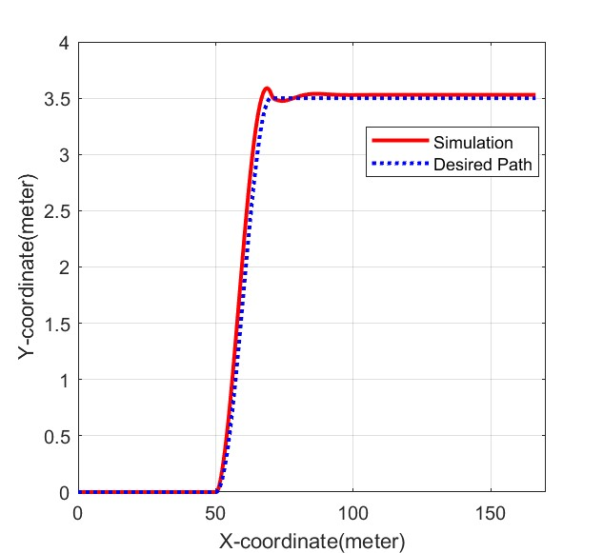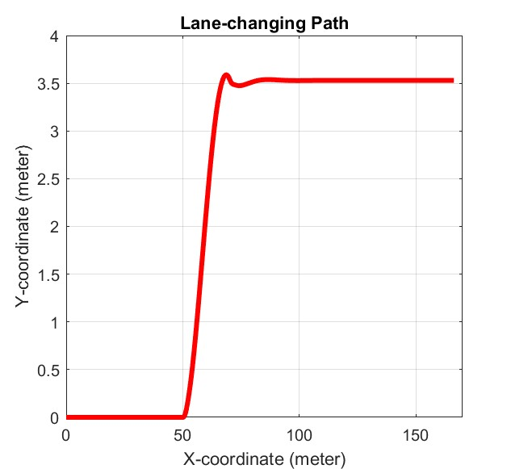

The vehicle's ability to accurately track the predefined path with minimal error suggests that the simulation model used in Simscape is accurate and valid. This is an important validation of the simulation model, as it demonstrates that the model can accurately predict the behavior of the vehicle in real-world situations. The ability to accurately simulate vehicle behavior is crucial for designing and optimizing vehicle control systems and can lead to improvements in safety and performance. Overall, the successful execution of the predefined path indicates that the simulation model in Simscape is reliable and can be used with confidence in the design and development of vehicle control systems.

# V. CONCLUSION AND FUTURE WORK

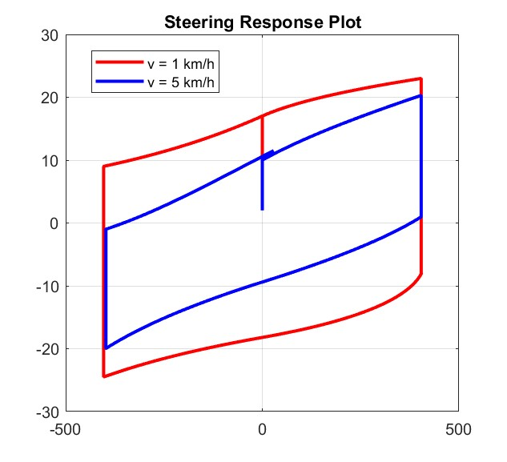

Figure 25: Result Comparision

The relationship between steering torque and vehicle speed is a critical aspect of the design and performance of modern steering systems in vehicles. The relationship has been studied extensively, with researchers seeking to understand the factors that influence the relationship and how it can be optimized to enhance vehicle safety and performance.

One of the most important findings in this area is that the steering torque required to achieve a given steering wheel angle decreases as vehicle speed increases. This relationship can be attributed to several factors, including the increased stability of the vehicle at higher speeds, the greater centrifugal forces acting on the vehicle, and the increased effectiveness of the steering system at higher speeds. The implications of this relationship are significant, as understanding it can help designers to optimize the design of steering components and systems for different vehicle speeds and driving conditions.

To further investigate this relationship, researchers have turned to simulation models to optimize steering system design and performance. These models simulate the behavior of the steering system in a virtual environment, allowing designers to test and optimize the system under various conditions. The validity of these simulation models is of utmost importance, as they can be used to predict vehicle behavior and performance in situations that are difficult or impossible to test in the real world.

As such, the validation of simulation models is a key area of research in this field. In recent years, researchers have developed several methods for validating these models, including comparing simulation results to data obtained from testing on a real vehicle. In one study, the validity of a simulation model was evaluated by comparing the simulation results to those obtained from testing on a real vehicle. The two sets of results were found to be similar, with the simulation model demonstrating good accuracy. In a lane-changing test case, the vehicle was able to maintain its trajectory with small deviations, indicating the model's validity.

By understanding the relationship between steering torque and vehicle speed, researchers and designers can optimize steering components and systems to improve safety and handling at higher speeds. This can be achieved by tailoring steering systems to provide the appropriate level of control and responsiveness for different vehicle speeds and driving conditions. The findings of this study provide valuable insights for the design and optimization of steering systems in vehicles, emphasizing the importance of considering the effects of vehicle speed on steering performance.

# Appendix

| **Tire Size** | **Camber** | **Caster** | **King Pin Angle** |
| --- | --- | --- | --- |
| 175/65R14 | -0°08' +/- 0°45' (-0.13° +/- 0.75°) | 4°41' +/- 0°45' (4.68° +/- 0.75°) | 11°14' (11.23°) |
| 185/60R15 | -0°08' +/- 0°45' (-0.13° +/- 0.75°) | 4°41' +/- 0°45' (4.68° +/- 0.75°) | 11°13' (11.21°) |

|  |
| --- |
|  |
| **No.** | **Parameter Name** | **Unit** | **Value** |
| 1 | Overall dimensions (length x width x height) | mm | 4300 x 1700 x 1460 |
| 2 | Wheelbase | mm | 2550 |
| 3 | Track width (front/rear) | mm | 1470/1460 |
| 4 | Curb weight | kg | 1055-1110 |
| 5 | Gross vehicle weight | kg | 1520 |
| 6 | Tires and wheels |  | 185/60R15 Alloy wheels |
| 7 | Steering wheel angle | degree | -405 -> 405 |

# VII. REFERENCE

1. Cossalter, Vittore. Motorcycle Dynamics. Lulu, 2010.
2. Genta. The Automotive Chassis. Springer International Publishing, 2020.
3. Hiremath, R. R., and Isha, T. B. “Modelling and Simulation of Electric Power Steering System Using Permanent Magnet Synchronous Motor.” IOP Conference Series: Materials Science and Engineering, vol. 561, no. 1, 2019, p. 012124, doi:10.1088/1757-899X/561/1/012124.
4. Jazar, Reza N. Vehicle Dynamics: Theory and Applications. Springer, 2008.
5. Nasir, M. Z., et al. “Hardware-in-the-Loop Simulation for Automatic Rack and Pinion Steering System.” Applied Mechanics and Materials, vols. 229-231, 2012, pp. 2135-2139, doi:10.4028/[www.scientific.net/AMM.229-231.2135](http://www.scientific.net/AMM.229-231.2135).
6. Nemes, Radu-Octavian, et al. “Integration of Real-Time Electric Power Steering System MATLAB/Simulink Model into National Instruments Veristand Environment.” 2018 IEEE 18th International Power Electronics and Motion Control Conference (PEMC), 2018, doi:10.1109/epepemc.2018.8521888.
7. Pacejka, Hans B. Tyres and Vehicle Dynamics. Butterworth-Heinemann, 2002.
8. Qun, Zhang, and Juhua, Hu. “Modeling and Simulation of the Electric Power Steering System.” 2009 Pacific-Asia Conference on Circuits, Communications and Systems, 2009, doi:10.1109/PACCS.2009.67.
9. Ingale, Amol. “Modeling Mass-Spring-Damper System Using Simscape.” Journal of Engineering Research and Application, no. Preprint, no date, doi:10.9790/9622-0801033033.
10. Sh., A., H., E., and A., E.-H. “Side-Stick Control of Power Rack and Pinion Steering System.” The International Conference on Applied Mechanics and Mechanical Engineering, vol. 12, no. 12, 2006, pp. 383-396, doi:10.21608/amme.2006.41261.
11. Setiawan, A. and Baharom, M. R. "Development of Force Feedback in Steering Systems: A Review." Journal of Mechanical Engineering and Sciences, vol. 9, no. 1, 2015, pp. 1573-1586, doi:10.15282/jmes.9.1.2015.12.0147.
12. Tuan, N. A., and Thang, N. V. "Determining the Vertical Force When Steering." Journal of Science and Technology, vol. 55, no. 3, 2017, pp. 7-14, doi:10.15625/2525-2518/55/3/9129.
13. Nguyen, V. H., et al. "Study on Low-Speed Steering Resistance Torque of Vehicles Considering Friction between Tire and Pavement." Journal of Mechanical Engineering Research and Developments, vol. 41, no. 4, 2018, pp. 51-60.
14. "Front Steering Gear Link." Toyota Vios / Soluna Vios, Japan Parts EU, 2010, <http://www.japan-parts.eu/toyota/gr/2010/vios-soluna-vios/ncp42l-eepskr/2_149310_015/powertrain-chassis/4505_front-steering-gear-link/1>.
15. Huu, Nguyen Ngoc and Quang, Tran Ngoc. "Real-Time Simulation of Electronic Power Steering System on TOYOTA VIOS." Proceedings of the 2nd Annual International Conference on Material, Machines and Methods for Sustainable Development (MMMS2020), edited by Bui Trong Long et al., Springer, 2021, pp. 273-281, doi:10.1007/978-3-030-69610-8_28.
16. Pang, Jong-Hyuk and Jang, Seong-Ho. "Steering Wheel Torque Control of Electric Power Steering by PD-Control." International Journal of Automotive Technology, vol. 12, no. 3, 2011, pp. 391-397, doi:10.1007/s12239-011-0050-5.
17. Inallu, Prasanthi and Raju, G. Jaya Krishna. "Design of Steering Wheel Force Feedback System with Active Disturbance Rejection Control." 2018 International Conference on Circuit, Power and Computing Technologies (ICCPCT), 2018, pp. 1-5, doi:10.1109/ICCPCT.2018.8473152.
18. Sharma, R., Ganai, P., Pare, V., Kanchwala, H., Srihari, S.J. (2023). Validation of a Steering System Mathematical Model via Test Rig Measurements. In: Gupta, V.K., Amarnath, C., Tandon, P., Ansari, M.Z. (eds) Recent Advances in Machines and Mechanisms. Lecture Notes in Mechanical Engineering. Springer, Singapore. <https://doi.org/10.1007/978-981-19-3716-3_13>
19. Kang, Seung-Woo and Oh, Jung-Hwan. "Active Return-to-Center Control Based on Torque and Angle Sensors for Electric Power Steering Systems." International Journal of Automotive Technology, vol. 22, no. 6, 2021, pp. 1867-1874, doi:10.1007/s12239-021-0177-7.
20. Đặng, Quý. Tính Toán Thiết Kế Ôtô. NXB Hồ Chí Minh, 2001.